**PLASTICS**

**HERO**



Plastics are foundational to countless industries, from packaging and automotive to electronics and construction. Flexicon designs its bulk handling solutions to streamline the movement, storage, and processing of plastic materials with maximum safety and efficiency.

**Button**: Talk To Us

**SHELF #1 - PRODUCT DESCRIPTION**

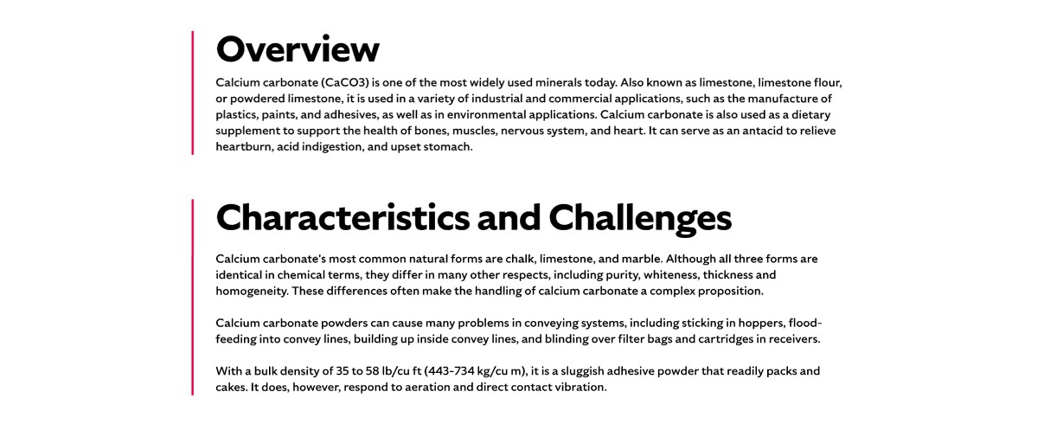

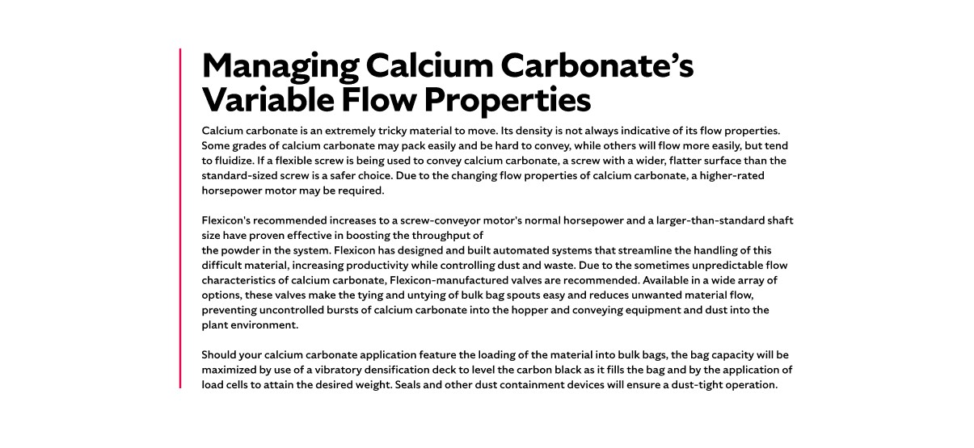

**Overview**Plastics encompass a wide range of materials, including thermoplastics and thermosets, each with unique properties and processing requirements. From free-flowing pellets to sticky powders and fragile regrind, plastic materials present diverse handling challenges. Flexicon systems are designed to manage these variations with precision, supporting applications in molding, extrusion, blending, and packaging. Whether you're conveying commodity resins or specialty compounds, Flexicon offers reliable solutions that maintain product integrity and operational efficiency.

**Characteristics and Challenges**Plastics are generally classified into two categories: thermoplastics and thermosets. Thermoplastics melt when heated, allowing them to be reshaped and solidified upon cooling—making them recyclable and versatile. Common thermoplastics include polyethylene, polypropylene, PVC, polystyrene, nylon, and polycarbonate. These are often produced as pellets for further processing. Within the industry, plastics are also categorized as commodity resins, which are low-cost and high-volume (e.g., PET, polypropylene), or specialty resins, which are engineered for specific applications and produced at lower volumes and higher costs. Specialty resins include engineering plastics like polyacetal, nylon, Teflon, and polycarbonate, which are used in demanding applications such as automotive and plumbing. Thermosets, on the other hand, permanently harden after molding and include materials like vulcanized rubber, acrylics, polyurethanes, and epoxies.

Handling plastic resins, whether pellets, flakes, or powders, requires specialized equipment to ensure smooth flow and effective dust control. Bulk bag dischargers should include accessories that stretch and elongate the bags to eliminate trapped material and promote consistent flow. Dust-tight seals and integrated dust collectors help contain airborne particles during discharge. Receiving hoppers must be properly vented and may require vibrators to assist flow, especially for resins that do not flow freely. For smaller packaging, bag dump stations with filtration systems are ideal. Conveying systems must be tailored to the resin’s properties. For example, flexible screw conveyors require the correct screw type to handle specific flow behaviors, and pneumatic systems must be carefully designed to reduce wear and prevent issues such as streamers or angel hair. To reduce friction and heat buildup, which can degrade resin quality, deflection elbows are recommended to preserve material integrity and protect downstream equipment.

**SHELF #2 - FLEXICON SOLUTIONS**

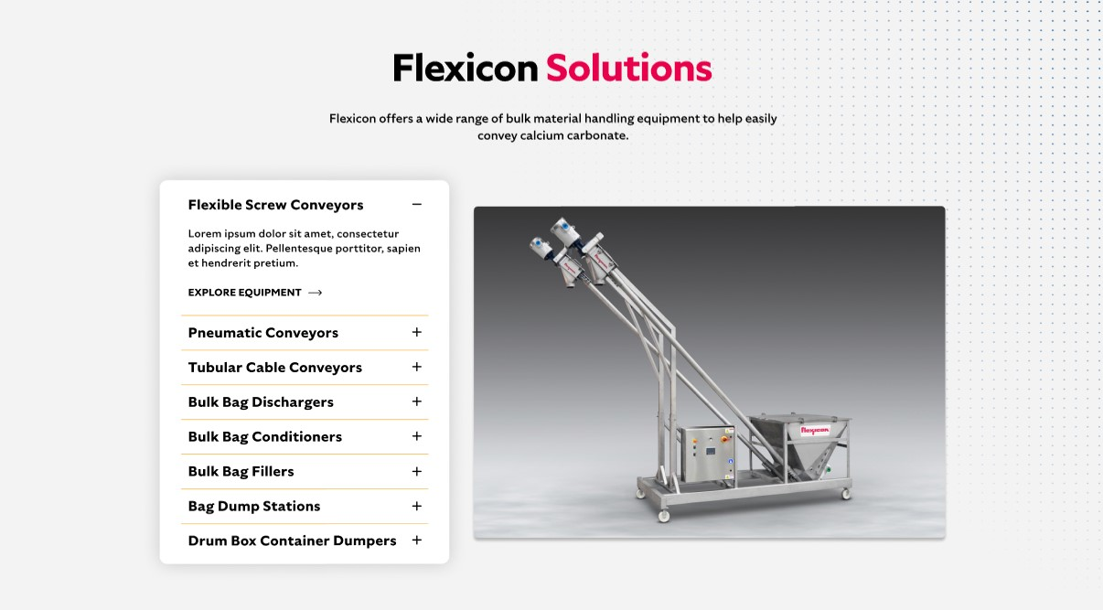

**Flexicon Solutions**

Flexicon offers a wide range of bulk material handling equipment to help easily convey plastics.

**Flexible Screw Conveyors:** Reliably transport plastic pellets, powders, and regrind—even those that tend to compact or smear during handling.

**Pneumatic Conveyors:** Move abrasive or dusty plastic materials through sealed systems that help maintain cleanliness and reduce airborne particles.

**Tubular Cable Conveyors:** Provide enclosed, low-impact conveying for delicate or irregularly shaped plastics with adaptable routing options.

**Bulk Bag Dischargers:** Discharge plastic resins from bulk bags with integrated systems that control dust and ensure smooth material flow.

**Bulk Bag Conditioners:** Break up hardened or compacted plastic contents inside bulk bags to support steady and uniform discharge.

**Bulk Bag Fillers:** Load plastic resins or powders into bulk bags with precision, using vibration and sealing features to minimize waste and dust.

**Bag Dump Stations:** Allow operators to manually empty plastic materials from smaller bags while capturing dust through built-in filtration.

**Drum/Box/Container Dumpers:** Empty plastic contents from drums or containers into processing equipment with minimal manual effort and dust release.

**SHELF #3: LIFETIME PERFORMANCE GUARANTEE**

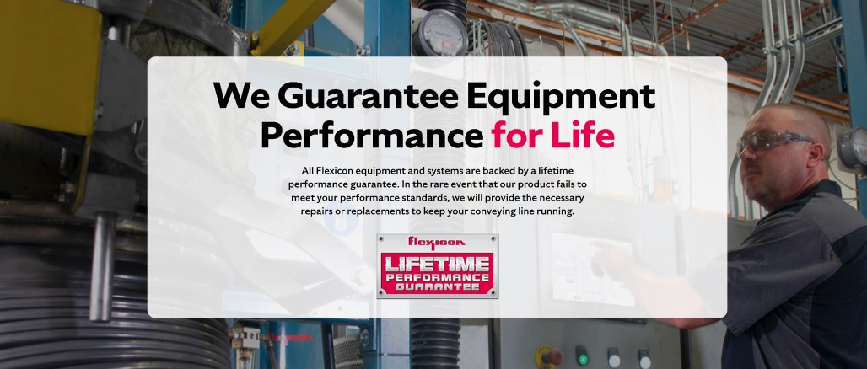

**Lifetime Performance Guarantee**

All Flexicon equipment and systems are backed by a lifetime performance guarantee. In the rare event that our product fails to meet your performance standards, we will provide the necessary repairs or replacements to keep your conveying line running.

**SHELF #4: CASE STUDIES**

